**ASSIGNMENT 6**

i.Design an ER diagram for an application that models a car-insurance company whose customers own one or more cars each. Analyse the requirements by identifying the entities, attributes, relationships, keys, constraints etc. Apply extended entity-relationship features to the design. Defend your design with proper assumptions and justifications. Map the ER model into a relational model.

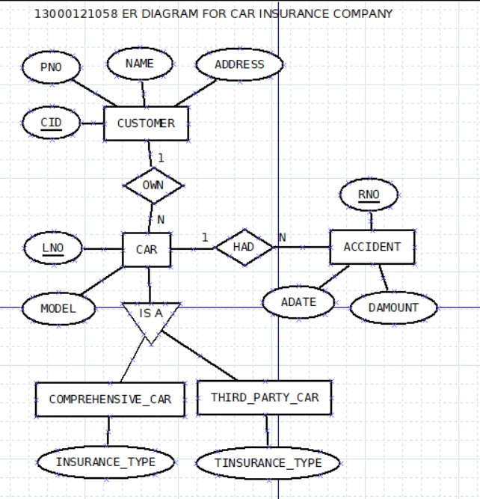

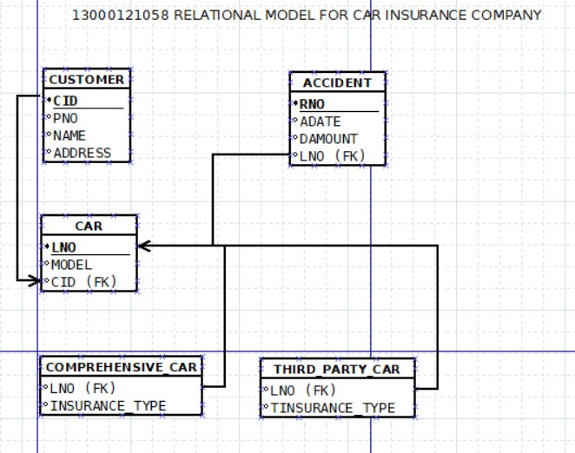

**ASSUMPTIONS**

1. A Customer can own more than one car. This indicates a one-to-many relationship between the `CUSTOMER` entity and the `CAR` entity, established by the `CID` attribute in the `CAR` table, which serves as a foreign key referencing the `CID` attribute in the `CUSTOMER` table.

2. A car can be owned by one customer at a time. This reflects the one-to-many relationship between the `CUSTOMER` entity and the `CAR` entity, enforced by the `CID` attribute in the `CAR` table, which references the `CID` attribute in the `CUSTOMER` table.

3. A car can have multiple accidents. This indicates a one-to-many relationship between the `CAR` entity and the `ACCIDENT` entity, represented by the `LNO` attribute in the `ACCIDENT` table, which acts as a foreign key referencing the `LNO` attribute in the `CAR` table.

4. For a particular accident, the record number is allotted for one car only. This reflects a one-to-one relationship between the `ACCIDENT` entity and the `CAR` entity, with each accident entity associated with only one car entity.This is enforced by the `LNO` attribute in the `ACCIDENT` table, which acts as a foreign key referencing the `LNO` attribute in the `CAR` table. The `RNO` attribute in the `ACCIDENT` table serves as the primary key, uniquely identifying each accident record.

5. A car can be comprehensive or third party depending on the type of insurance it has. This implies a classification of cars based on their insurance type, with two subtypes: Comprehensive Car and Third-Party Car. The ER diagram can represent this using the subtype-supertype relationship feature, where `CAR` is the supertype entity and `Comprehensive_Car` and `Third_Party_Car` are the subtypes. The subtype entities (`Comprehensive_Car` and `Third_Party_Car`) are associated with the `CAR` entity through foreign key constraints. Subtype-specific attributes (`INSURANCE_TYPE` for both subtypes) differentiate between them.

ii.Create tables, populate with data and construct queries (advanced) in SQL to extract information from the car insurance company’s database.

Consider a car-insurance company whose customers own one or more cars each. Each car has associated with it zero to any number of recorded accidents.

CREATE TABLE CUSTOMER (

CID VARCHAR2(8) PRIMARY KEY CONSTRAINT C1 CHECK(CID LIKE 'C%'),

NAME VARCHAR2(20),

ADDRESS VARCHAR2(20),

PNO VARCHAR2(20));

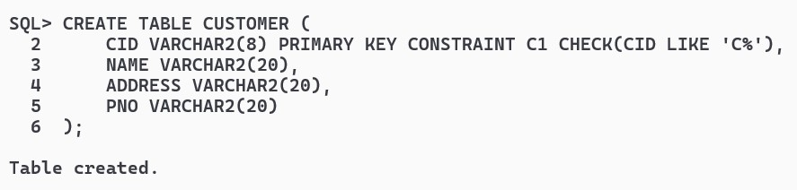

CREATE TABLE CAR (

LNO VARCHAR2(10) PRIMARY KEY ,

MODEL VARCHAR2(20),

CID VARCHAR2(8),

CONSTRAINT CARFK1 FOREIGN KEY (CID) REFERENCES CUSTOMER(CID) ON DELETE CASCADE);

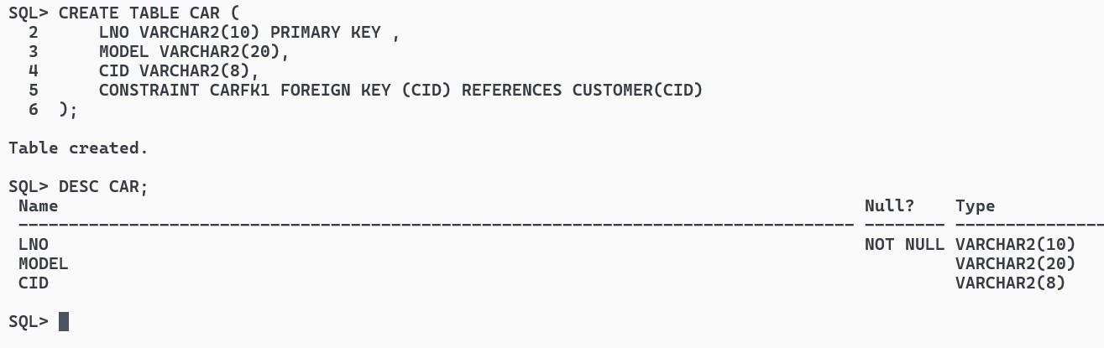

CREATE TABLE ACCIDENT (

RNO VARCHAR2(10) PRIMARY KEY,

LNO VARCHAR2(10),

ADATE DATE,

DAMOUNT NUMBER(10, 2),

CONSTRAINT AFK1 FOREIGN KEY (LNO) REFERENCES CAR(LNO) ON DELETE CASCADE);

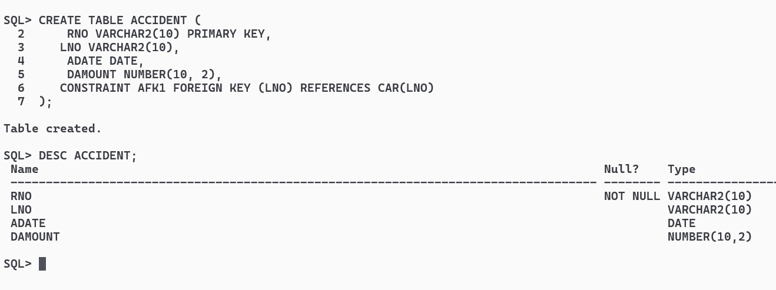

CREATE TABLE Comprehensive_Car (

LNO VARCHAR2(10),

INSURANCE_TYPE VARCHAR2(20),

CONSTRAINT CCFK1 FOREIGN KEY (LNO) REFERENCES CAR(LNO) ON DELETE CASCADE);

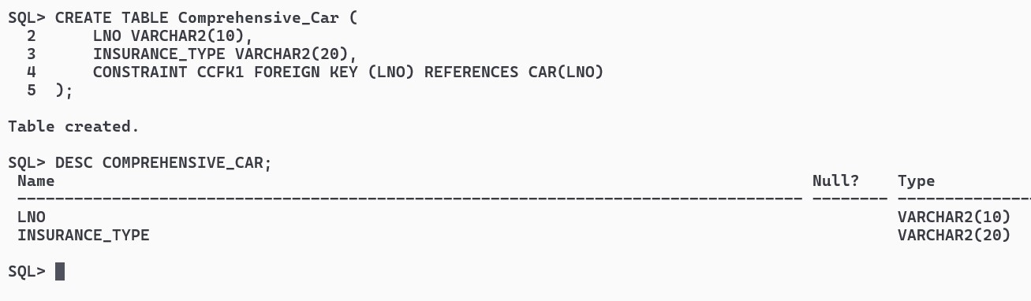

CREATE TABLE Third_Party_Car (

LNO VARCHAR2(10),

TINSURANCE_TYPE VARCHAR(50),

CONSTRAINT TPCFK1 FOREIGN KEY (LNO) REFERENCES CAR(LNO) ON DELETE CASCADE);

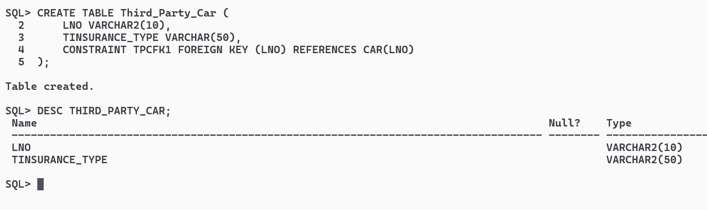

iii.Enter at least 5 sets of records in each table form created in part (ii).

INSERT ALL

INTO CUSTOMER VALUES ('C1', 'ARKA', 'AC-13', '9330450430')

INTO CUSTOMER VALUES ('C2', 'RAMU', 'BD-20', '8910062339')

INTO CUSTOMER VALUES ('C3', 'JADU', 'CC-21', '9007523577')

INTO CUSTOMER VALUES ('C4', 'SIDD', 'CC-10', '7014561289')

INTO CUSTOMER VALUES ('C5', 'JOHN', 'EF-13', '8910120012')

SELECT * FROM DUAL;

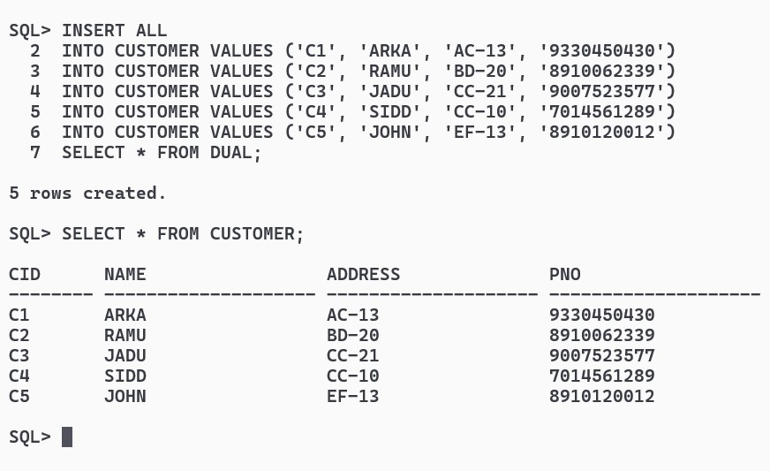

INSERT ALL

INTO CAR VALUES ('AIAPC2010', 'Toyota Camry', 'C1')

INTO CAR VALUES ('AIDPC2010', 'Scorpio', 'C2')

INTO CAR VALUES ('AICPC2010', 'Ford Mustang', 'C3')

INTO CAR VALUES ('AIEPC2010', 'Chevrolet Cruze', 'C4')

INTO CAR VALUES ('AIBPC2010', 'BMW X5', 'C5')

SELECT * FROM DUAL;

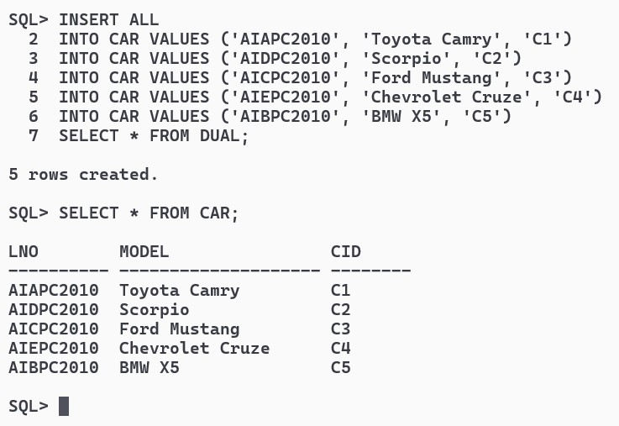

INSERT ALL

INTO ACCIDENT VALUES ('FIR001', 'AIAPC2010', TO_DATE('19-03-2024', 'DD-MM-YYYY'), 15000.00)

INTO ACCIDENT VALUES ('FIR002', 'AIDPC2010', TO_DATE('20-03-2024', 'DD-MM-YYYY'), 20000.00)

INTO ACCIDENT VALUES ('FIR003', 'AICPC2010', TO_DATE('21-03-2024', 'DD-MM-YYYY'), 18000.00)

INTO ACCIDENT VALUES ('FIR004', 'AIEPC2010', TO_DATE('22-03-2024', 'DD-MM-YYYY'), 22000.00)

INTO ACCIDENT VALUES ('FIR005', 'AIBPC2010', TO_DATE('23-03-2010', 'DD-MM-YYYY'), 25000.00)

SELECT * FROM DUAL;

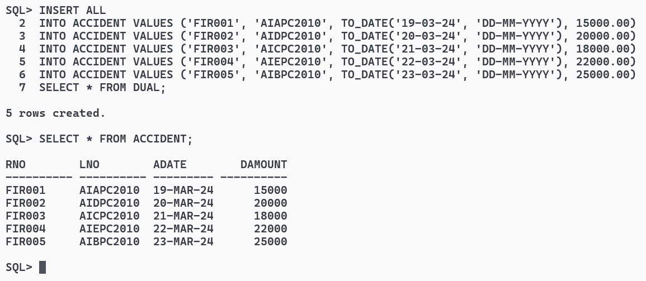

INSERT ALL

INTO Comprehensive_Car VALUES ('AIAPC2010', 'Comprehensive1')

INTO Comprehensive_Car VALUES ('AIDPC2010', 'Comprehensive2')

INTO Comprehensive_Car VALUES ('AICPC2010', 'Comprehensive3')

INTO Comprehensive_Car VALUES ('AIEPC2010', 'Comprehensive3')

INTO Comprehensive_Car VALUES ('AIBPC2010', 'Comprehensive1')

SELECT * FROM DUAL;

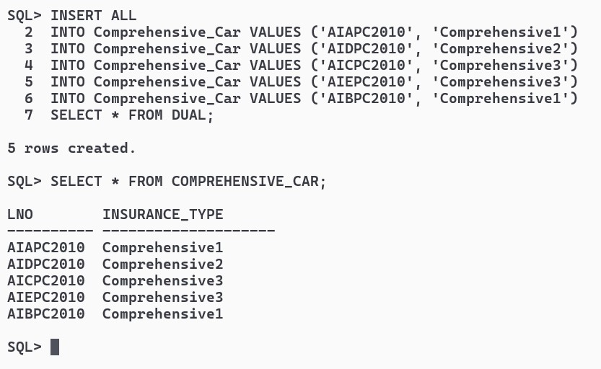

INSERT ALL

INTO Third_Party_Car VALUES ('AIAPC2010', 'Third-Party1')

INTO Third_Party_Car VALUES ('AIDPC2010', 'Third-Party1')

INTO Third_Party_Car VALUES ('AICPC2010', 'Third-Party3')

INTO Third_Party_Car VALUES ('AIEPC2010', 'Third-Party2')

INTO Third_Party_Car VALUES ('AIBPC2010', 'Third-Party2')

SELECT * FROM DUAL;

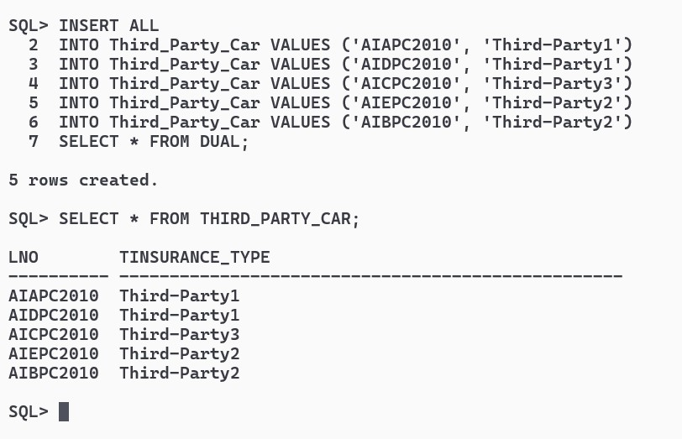

iv.Write and run the following SQL queries for your database:

a.Find the total number of people who owned cars that were involved in accidents in 2010.

SELECT COUNT(C.CID) FROM CUSTOMER C

JOIN CAR CA ON CA.CID=C.CID

JOIN ACCIDENT A ON A.LNO = CA.LNO

WHERE EXTRACT(YEAR FROM A.ADATE)=2010;

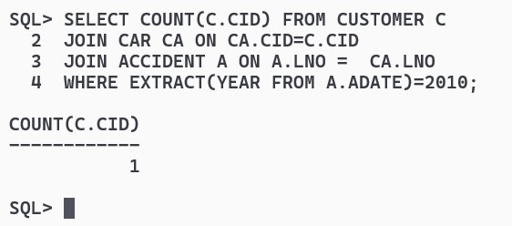

b.Find the number of accidents in which the cars belonging to “XYZ” were involved.

SELECT COUNT(*) AS Total_Accidents

FROM ACCIDENT A

JOIN CAR CA ON A.LNO = CA.LNO

JOIN CUSTOMER C ON CA.CID = C.CID

WHERE C.NAME = 'XYZ';

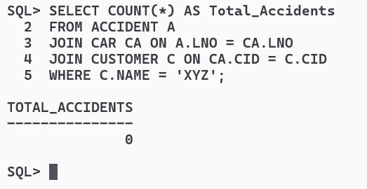

c.Add a new accident to the database; assume any values for required attributes.

INSERT INTO ACCIDENT (RNO, LNO, ADATE, DAMOUNT)

VALUES ('FIR006', 'AIAPC2010', TO_DATE('12-02-2010', 'DD-MM-YYYY'), 20000.00);

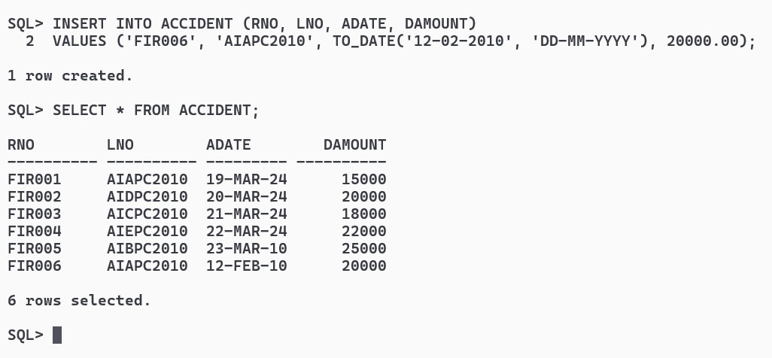

d.Delete the model ‘Scorpio belonging to “ABC”.

DELETE FROM CAR WHERE MODEL = 'Scorpio' AND CID = 'ABC';

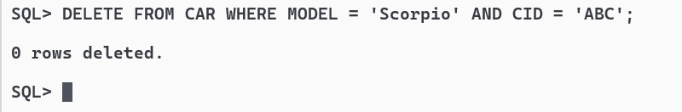

e.Update the damage amount for the car with licence number “AIBPC2010” in the accident with report number “FIR271” to Rs. 5000.

